**What is Convolutional Neural Network(CNN)?**

* A [Convolutional Neural Network](https://www.geeksforgeeks.org/neural-networks-a-beginners-guide/)(CNN) is a type of [deep learning algorithm](https://www.geeksforgeeks.org/deep-learning-introduction-to-long-short-term-memory/) that is particularly well-suited for image recognition and processing tasks.
* It is made up of multiple layers, including convolutional layers, [pooling layers](https://www.geeksforgeeks.org/cnn-introduction-to-pooling-layer/), and fully connected layers.
* The architecture of CNNs is inspired by the visual processing in the human brain, and they are well-suited for capturing hierarchical patterns and spatial dependencies within images.

**CNN Architecture :**

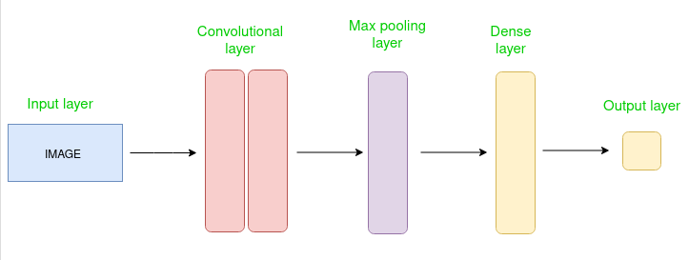

The Convolutional layer applies filters to the input image to extract features, the Pooling layer downsamples the image to reduce computation, and the fully connected layer makes the final prediction. The network learns the optimal filters through backpropagation and gradient descent.

Key components of a Convolutional Neural Network include:

* **Input Layers:** It’s the layer in which we give input to our model. In CNN, Generally, the input will be an image or a sequence of image
* **Convolutional Layers:** These layers apply convolutional operations to input images, using filters to detect features such as edges, textures, and more complex patterns.
* **Activation Function:** Non-linear activation functions, such as Rectified Linear Unit (ReLU), introduce non-linearity to the model, allowing it to learn more complex relationships in the data.
* **Pooling Layers:** Pooling layers are used to reduce the dimensions pf the feature map, thus it reduces the number of parameter to learn and the amount of computation performed in the network.
* **Flattening:**The resulting feature maps are flattened into a one-dimensional vector after the convolution and pooling.
* **Fully Connected Layers:** These layers are responsible for making predictions based on the high-level features learned by the previous layers. They connect every neuron in one layer to every neuron in the next layer.
* **Output Layer:** The **output layer** of a CNN typically uses a logistic function, such as **sigmoid** or **softmax**, to convert the raw output from the fully connected layers into probability scores for classification tasks.

**Convolutional Neural Network Training :**

CNNs are trained using a supervised learning approach. This means that the CNN is given a set of labeled training images. The CNN then learns to map the input images to their correct labels.

The training process for a CNN involves the following steps:

1. **Data Preparation:** The training images are preprocessed to ensure that they are all in the same format and size.
2. **Loss Function:** A [loss function](https://www.geeksforgeeks.org/ml-common-loss-functions/) is used to measure how well the CNN is performing on the training data. The loss function is typically calculated by taking the difference between the predicted labels and the actual labels of the training images.
3. **Optimizer:** An optimizer is used to update the weights of the CNN in order to minimize the loss function.
4. **Backpropagation:** [Backpropagation](https://www.geeksforgeeks.org/backpropagation-in-machine-learning/) is a technique used to calculate the gradients of the loss function with respect to the weights of the CNN. The gradients are then used to update the weights of the CNN using the optimizer.

**CNN Evaluation:**

* **Accuracy:** Accuracy is the percentage of test images that the CNN correctly classifies.
* **Precision:** Precision is the percentage of test images that the CNN predicts as a particular class and that are actually of that class. (positive predictions made by the model are actually correct )
* **Recall:** Recall is the percentage of test images that are of a particular class and that the CNN predicts as that class. (Lower recall and higher precision give you great accuracy)
* **F1 Score:** The F1 Score is a harmonic mean of precision and recall. Its range is [0,1].

**CNN models :**

* **LeNet-5:** Recognizes handwritten digits with a simple network structure.
* **AlexNet:** Revolutionized image classification with a deep network in 2012.
* **VGGNet:** Known for its very deep architecture using small 3x3 filters.
* **MobileNet:** Optimized for mobile and embedded applications with lightweight architecture.

**Advantages of CNNs:**

1. Good at detecting patterns and features in images, videos, and audio signals.
2. Robust to translation, rotation, and scaling invariance.
3. End-to-end training, no need for manual feature extraction.
4. Can handle large amounts of data and achieve high accuracy.

**Disadvantages of CNNs:**

1. Computationally expensive to train and require a lot of memory.
2. Can be prone to overfitting if not enough data or proper regularization is used.
3. Requires large amounts of labeled data.
4. Interpretability is limited, it’s hard to understand what the network has learned.

**Applications of CNN**

* **Image classification:** They can be used to classify images into different categories, such as cats and dogs, cars and trucks, and flowers and animals.
* **Object detection:** CNNs can be used to detect objects in images, such as people, cars, and buildings.
* **Image segmentation:** This is useful for applications such as medical imaging and robotics.
* **Video analysis:** CNNs can be used to analyze videos, such as tracking objects in a video or detecting events in a video.